LAB 5

Write Python code to implement the following. Consider dataset files as “iris.csv” and “drug.csv”
1. Build a DecisionTree classifier to classify IRIS flower dataset Use 80% of data for training and 20% for testing. Display accuracy score and confusion matrix of the trained model on test data
import pandas as pd
df1=pd.read_csv("iris.csv")
from sklearn.tree import DecisionTreeClassifier
from sklearn.model_selection import train_test_split
from sklearn.metrics import accuracy_score, confusion_matrix

X_iris = df1[['sepal_length', 'sepal_width', 'petal_length', 'petal_width']]
y_iris = df1['species']

# Split data into training and testing sets (80% train, 20% test)
X_train_iris, X_test_iris, y_train_iris, y_test_iris = train_test_split(X_iris, y_iris, test_size=0.2, random_state=42)

# Build and train the Decision Tree classifier
dtc_iris = DecisionTreeClassifier(random_state=42)
dtc_iris.fit(X_train_iris, y_train_iris)

y_pred_iris = dtc_iris.predict(X_test_iris)
accuracy_iris = accuracy_score(y_test_iris, y_pred_iris)
print(f"Accuracy Score for Iris Dataset: {accuracy_iris:.4f}")

conf_matrix_iris = confusion_matrix(y_test_iris, y_pred_iris)
print("\nConfusion Matrix for Iris Dataset:")
print(conf_matrix_iris)

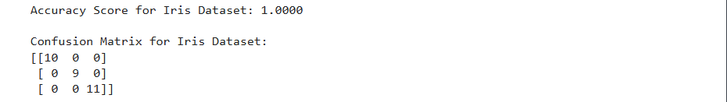
2. Build a DecisionTree classifier to classify Drugdataset Use 80% of data for training and 20% for testing. Display accuracy score and confusion matrix of the trained model on test data.
df2=pd.read_csv("drug.csv")
from sklearn.preprocessing import LabelEncoder
X_drug = df2.drop('Drug', axis=1)
y_drug = df2['Drug']
le = LabelEncoder()

X_drug['Sex'] = le.fit_transform(X_drug['Sex'])
X_drug['BP'] = le.fit_transform(X_drug['BP'])
X_drug['Cholesterol'] = le.fit_transform(X_drug['Cholesterol'])

# Split data into training and testing sets (80% train, 20% test)
X_train_drug, X_test_drug, y_train_drug, y_test_drug = train_test_split(X_drug, y_drug, test_size=0.2, random_state=42)

# Build and train the Decision Tree classifier
dtc_drug = DecisionTreeClassifier(random_state=42)
dtc_drug.fit(X_train_drug, y_train_drug)

y_pred_drug = dtc_drug.predict(X_test_drug)

accuracy_drug = accuracy_score(y_test_drug, y_pred_drug)
print(f"Accuracy Score for Drug Dataset: {accuracy_drug:.4f}")

conf_matrix_drug = confusion_matrix(y_test_drug, y_pred_drug)
print("\nConfusion Matrix for Drug Dataset:")
print(conf_matrix_drug)

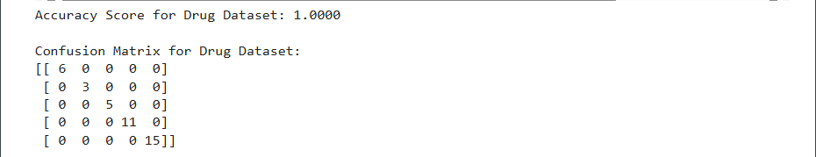
3.Write Python code to implement the following. Consider dataset file “petrol_consumption.csv” Build a RegressionTree to predict petrol consumption Use 80% of data for training and 20% for testing. Display “Mean Absolute Error, Mean Squared Error, Root Mean Squared Error” for test data.
df3=pd.read_csv("petrol_consumption.csv")
from sklearn.tree import DecisionTreeRegressor
from sklearn.model_selection import train_test_split
from sklearn.metrics import mean_absolute_error, mean_squared_error
import numpy as np
import pandas as pd

X_petrol = df3.drop('Petrol_Consumption', axis=1)
y_petrol = df3['Petrol_Consumption']

# Split data into training and testing sets (80% train, 20% test)
X_train_petrol, X_test_petrol, y_train_petrol, y_test_petrol = train_test_split(X_petrol, y_petrol, test_size=0.2, random_state=42)

dtr_petrol = DecisionTreeRegressor(random_state=42)
dtr_petrol.fit(X_train_petrol, y_train_petrol)

y_pred_petrol = dtr_petrol.predict(X_test_petrol)

mae_petrol = mean_absolute_error(y_test_petrol, y_pred_petrol)
mse_petrol = mean_squared_error(y_test_petrol, y_pred_petrol)
rmse_petrol = np.sqrt(mse_petrol)

print(f"Mean Absolute Error (MAE): {mae_petrol:.4f}")
print(f"Mean Squared Error (MSE): {mse_petrol:.4f}")
print(f"Root Mean Squared Error (RMSE): {rmse_petrol:.4f}")

